

**Department of Computer Applications**

# LAB RECORD

**MASTER OF COMPUTER APPLICATIONS**

**SEMESTER 1**

**A250201/CA130U WEB PROGRAMMING LAB**

**Name: Faseeh Haris M**

**Register Number: MITS25PMCA028**

**Month: December Year: 2025**



## Certificate

*Certified that this is the Bonafide Record of Practical work done in the Vinton Cerf Lab of Muthoot Institute of Technology and Science (Autonomous) by***Faseeh Haris M, MITS25PMCA028** *for the partial fulfillment of the requirement for the award of the degree of Master of Computer Applications during the academic year 2025-2026.*

Faculty in Charge Head of the Department

Dr. Saritha K

University Exam Reg. No**:**

Date of Examination:

Internal Examiner External Examiner



**Vision of Institute**

To be a centre of excellence for learning and research in engineering and technology, producing intellectually well-equipped and socially committed citizens possessing an ethical value system.

**Mission of Institute**

* Offer well-balanced programme of instruction, practical exercise and opportunities in technology.
* Foster innovation and ideation of technological solutions on sustainable basis.
* Nurture a value system in students and engender in them a spirit of inquiry.

**INDEX**

|  |  |  |  |  |
| --- | --- | --- | --- | --- |
| **Sl.**  **No** | **Experiment** | **Date** | **Page No.** | |
| **CO1** | **Develop well-structured web pages using markup language features to organise content and layout.** |  | | |
| 1 | Create an HTML webpage to design your CV which should showcase the use of text  formatting tags, image embedding, tables, lists, and links within a page and also Link to  multiple web pages. | 25-09-25 | | 1 | |
| 2 | Create a web page of two parts,  Part 1: MCA student registration form  Part 2: Webpage of the college. Use frames and various form elements to create the webpage. | 03-10-25 | | 4 | |
| 3 | Create One Webpage about your hometown and its tourist attractions using Html, and External, Internal, and inline CSS. The following elements should be included in the webpage: 1. Html text formatting 2. Links to Wikipedia pages for further references 3. External, Internal, and Inline CSS 4. CSS should include font colour, positioning, background colours, text alignment etc. 5. Images of the hometown and its attractions.  6. Usage of div elements for styling. | 04-10-25 | | 10 | |
| 4 | Create MITS college Website with the help of frames, style sheets, background colours, images, tables, and lists. There should be **multiple webpages** which are easily navigable by hyperlinks. Apply style sheets as well as floating, mixed, and navigation frames to design the webpages. | 05-10-25 | | 16 | |
| 5 | Apply positioning methods of elements on a webpage with div elements and their corresponding classes using two external stylesheets. Compare the output with absolute, and relative positioning of div elements. | 06-10-25 | | 27 | |
| **CO2** | **Apply client-side scripting techniques to enforce input validation and enhance user**  **interaction.** | | | |
| 6 | **Apply client-side scripting techniques to enforce input validation and enhance user interaction.** | 07-11-25 | | 31 | |
| 7 | Generate a calendar using JavaScript code by getting the year and month from the user. | 08-11-25 | | 39 | |
| 8 | Create a program using the JavaScript Event Listener to add multiple events on the same button. | 09-11-25 | | 43 | |
| 9 | Develop a JavaScript Event Handling mechanism to change the background colour of an HTML page. | 10-11-25 | | 45 | |
| 10 | Create an HTML page to display a new image and text when the mouse comes over the existing content in the page using JavaScript Event Handling mechanism. | 11-11-25 | | 47 | |
| 11 | Create a HTML registration form and validate the form using JavaScript code. The validation should include the following: 1. Name validation/Mandatory field validation 2. password validation 3. Email validation 4. Mobile number validation | 12-11-25 | | 50 | |
| 12 | Design and develop a complete online exam using Html, CSS and JavaScript. Minimum 4-5 questions should be in the online exam, and the results should be displayed on completion. | 13-11-25 | | 53 | |
| **CO3** | **Create functional components using both client-side and server-side scripting to support dynamic web behaviour.** |  | | |
| 13 | Build a PHP code to store name of students in an array and display it using print_r function. Sort and display the same using asort & arsort functions. | 29-11-25 | | 64 | |
| 14 | Build a PHP code to store name of Indian Cricket players in an array and display the same in HTML table. | 30-11-25 | | 66 | |
| 15 | Design a registration form in HTML, and do necessary server side validations using PHP. | 01-12-25 | | 68 | |
| 16 | Develop a user-friendly electricity bill calculator using HTML and PHP. Collect the consumer data, and the units used, through an input form. Based on the given tariff, calculate the consumer bill amount. | 02-12-25 | | 72 | |
| **CO4** | **Develop programs to link front-end interfaces with back-end databases to enable data storage, retrieval, and processing.** |  | | |
| 17 | Count the occurrences of each word in a line of text. | 03-12-25 | | 75 | |
| **CO5** | Develop a PHP program to connect to a database and retrieve data from a table and show the details in a neat format. |  | | |
| 18 | Develop an application in PHP and MySQL, to accept book details viz. Book id, title, authors, edition and publisher from an HTML form in a web page and save the records in a MySQL database on submission. The program also should include a search function given the author's name, and display the search results. | 04-12-25 | | 77 | |

**Lab Cycle 1**

**CO1: Explore markup languages features and create interactive web pages using them.**

**PROGRAM 1:**

Create an HTML webpage to design your CV which should showcase the use of text formatting tags, image embedding, tables, lists, and links within a page and also Link to multiple web pages.

**PROGRAM CODE:**

**Faseeh Haris-CV.html**

<html>

<head>

<title>Faseeh Haris M - CV</title>

</head>

<body>

<center><h1>FASEEH HARIS M</h1></center>

<center><img src="FASEEH.jpg" width="120" height="150"></center>

<center> <p>Kannur, Kerala | faseehharis.inbox@gmail.com | +91 9447667596 </p></center>

<hr>

<center><h2><u>Professional Summary</u></h2></center>

<p>I’m <b>Faseeh Haris</b>, an MCA student at Muthoot Institute of Technology and Science (MITS) under APJ Abdul Kalam Technological University (KTU), and a BCA graduate from Wadihuda Institute of Research and Advanced Studies (WIRAS), Kannur University. I’m passionate about technology, coding, and building practical digital solutions. I’m always eager to learn, grow, and contribute to the world of software and web development. </p>

<center><a href="education.html"><h2>Education<h2></a></center>

<h2><u>Skills</u></h2>

<ul>

<li>C, C++, Python, Java</li>

<li>HTML, CSS, Javascript</li>

<li>Flutter</li>

</ul>

<h2><u>Project</u></h2>

<ul>

<li><b>College-eVoting – Blockchain based College Election System</b> – HTML, CSS, Bootstrap, JavaScript, Flutter, Python, Dart, MySQL. </li>

</ul>

<u><h2>Experience</h2></u>

<ul>

<li><b>Project Intern</b> – RISS Technologies (Oct 2024 - Mar 2025) </li>

</ul>

<p>Completed my academic project titled <b>College-eVoting</b> using Python and Flutter, under the guidance of senior developers. </p>

<h2><u>Achievements</u></h2>

<ul>

<li><b>First Prize in Zaul (Star of the Zeitgeist) at ZEITGEIST</b> - National level IT Fest hosted by Kannur University</li>

<li><b>Second Prize in Gaming at Concurso’24</b> - Intercollegiate IT Fest hosted by St Joseph's College</li>

</ul>

</body>

</html>

**education.html**

<html>

<body>

<center><table border="1">

<tr>

<th colspan="3"><h2>EDUCATION QUALIFICATIONS<h2></th>

</tr>

<tr>

<th>Education</th>

<th>Institution</th>

<th>Year of passing</th>

</tr>

<tr>

<td>Masters in Computer Application</td>

<td>Muthoot Institution of Technology & Science</td>

<td>Currently pursuing</td>

</tr>

<tr>

<td>Bachelors in Computer Application</td>

<td>Wadihuda Institute of Research and Advanced Studies</td>

<td>2025</td>

</tr>

<tr>

<td>XII</td>

<td>GHSS Cheruthazham</td>

<td>2022</td>

</tr>

<tr>

<td>X</td>

<td>PJHSS</td>

<td>2020</td>

</tr>

</table> </center>

<center><a href="Faseeh Haris-CV.html"><h2>Back to Main</a></center>

</body>

</html>

**OUTPUT:**

**Faseeh Haris-CV.html**

**education.html**

**PROGRAM 2:**

Create a web page of two parts,

Part 1: MCA student registration form

Part 2: Webpage of the college. Use frames and various form elements to create the webpage.

**PROGRAM CODE:**

**Frameset:**

**main.html**

<html>

<head>

<title>MCA Registration & College Info</title>

</head>

<frameset cols="45%,55%">

<frame src="forms.html" name="registrationFrame">

<frame src="clg.html" name="collegeInfoFrame">

</frameset>

</html>

**forms.html**

<html>

<head>

<title>MCA Student Registration</title>

</head>

<body bgcolor="#E6E6FA">

<h2 align="center" style="color: navy;"><u>MCA STUDENT

REGISTRATION FORM</u></h2>

<form>

<fieldset style="width: 80%; margin: 0 auto; padding: 20px;">

<legend style="font-weight: bold; color: navy;">Personal Details</legend>

<label for="fullName">Applicant Name:</label><br>

<input type="text" id="fullName" name="fullName" size="40"><br><br>

<label for="dob">Date of Birth:</label><br>

<input type="date" id="dob" name="dob"><br><br>

<label for="aadhaar">Aadhaar Number (Last 4 digits):</label><br>

<input type="text" id="aadhaar" name="aadhaar" maxlength="4"

pattern="[0-9]{4}"><br><br> <label for="phone">Contact

Number:</label><br>

<input type="tel" id="phone" name="phone"><br><br>

<label for="email">Email Address:</label><br>

<input type="email" id="email" name="email" size="40"><br><br>

<label for="password">Set Password:</label><br>

<input type="password" id="password" name="password"><br><br>

<label>Gender:</label>

<input type="radio" id="genderMale" name="gender" value="male"> <label

for="genderMale">Male</label>

<input type="radio" id="genderFemale" name="gender" value="female">

<label for="genderFemale">Female</label>

<input type="radio" id="genderOther" name="gender" value="other"> <label

for="genderOther">Prefer not to say</label> <br><br>

<label for="address">Permanent Address:</label><br>

<textarea id="address" name="address" rows="4"

cols="30"></textarea><br><br>

<label for="course">UG Stream:</label>

<select id="course" name="course">

<option value="">-- Choose One --</option>

<option value="BCA">BCA</option>

<option value="Bsc_CS">B.Sc. Computer Science</option>

<option value="Bcom">B.Com</option>

<option value="Bsc_Chem">B.Sc. Chemistry</option>

<option value="Bsc_Phy">B.Sc. Physics</option>

<option value="Bsc_Math">B.Sc. Mathematics</option>

<option value="Other">Other</option>

</select><br><br>

<label>Interests:</label><br>

<input type="checkbox" id="coding" name="interest1" value="coding">

<label for="coding">Programming/Coding</label><br>

<input type="checkbox" id="reading" name="interest2" value="reading">

<label for="reading">Literature/Reading</label><br>

<input type="checkbox" id="sports" name="interest3" value="sports"> <label

for="sports">Team Sports</label><br>

<input type="checkbox" id="tech" name="interest4" value="tech"> <label

for="tech">Gadgets/Technology</label><br><br> <input type="submit"

value="Submit Application" style="background-color: navy; color: white;

padding: 10px 20px;">

<input type="reset" value="Reset Form" style="background-color: navy; color:

white; padding: 10px 20px;">

</fieldset>

</form>

</body>

</html>

**clg.html**

<html>

<head>

<title>College Profile</title>

</head>

<body bgcolor="#F5F5DC">

<div align="center">

<img src="img-1.png" width="150" height="100"><br>

<font color="#800000"><h1><b>MUTHOOT INSTITUTE OF

TECHNOLOGY AND SCIENCE (MITS)</b></h1></font>

<img src="img-2.webp" width="550" height="300">

</div>

<hr>

<h2 align="center" style="color: #800000; text-decoration:

underline;">Institution Overview</h2>

<p style="text-align: justify; padding: 0 15px;">

Muthoot Institute of Technology and Science (MITS) is a premier selffinancing

technical institution offering undergraduate and postgraduate

engineering and MCA programmes. It is proudly promoted by the Muthoot M.

George Institute of Technology, a Section 25 Company under the esteemed

Muthoot Group. MITS is strategically located in the thriving industrial belt of

Kochi, offering proximity to major IT hubs like Smart City and Info Park,

situated approximately 15 kilometers from Vytilla Junction on the Cochin-

Madurai National Highway.

<br><br>

The promoters are deeply committed to establishing MITS as a true center of

excellence, with a core focus on merit and quality education. This "temple of

learning" is equipped with state-of-the-art infrastructure and boasts a faculty of

highly qualified and proficient teachers across various engineering and allied

disciplines, ensuring the harmonious development of all its students within a

conducive academic environment.

</p>

<h3><font color="#800000">Academic Programs Offered</font></h3>

<ul style="list-style-type: square; padding-left: 40px;">

<li>B.Tech in Civil Engineering (CE)</li>

<li>B.Tech in Computer Science & Engineering (CSE)</li>

<li>B.Tech in Electronics & Communication Engineering (ECE)</li>

<li>B.Tech in Electrical & Electronics Engineering (EEE)</li>

<li>B.Tech in Mechanical Engineering (ME)</li>

<li>B.Tech in CSE (Artificial Intelligence specialization)</li>

<li>B.Tech in Artificial Intelligence & Data Science (AI & DS)</li>

<li>B.Tech in Cyber Security</li>

<li>M.Tech in Artificial Intelligence & Data Science</li>

<li>M.Tech in Cyber Security</li>

<li>Master of Computer Applications (MCA)</li>

</ul>

<h3><font color="#800000">Get in Touch</font></h3>

<p>

OFFICIAL ADDRESS:<br>

Muthoot Institute of Technology and Science<br>

Varikoli P.O, Puthencruz- 682308

<br><br>

CONTACT NUMBERS:<br>

(0484) 2732111<br>

(0484) 2732100

<br><br>

EMAIL CORRESPONDENCE:<br>

info@mgits.ac.in

</p>

</body>

</html>

**OUTPUT:**

**PROGRAM 3:**

Create One Webpage about your hometown and its tourist attractions using Html, and External, Internal, and inline CSS. The following elements should be included in the webpage:

1. Html text formatting
2. Links to Wikipedia pages for further references
3. External, Internal, and Inline CSS
4. CSS should include font colour, positioning, background colours, text alignment etc.
5. Images of the hometown and its attractions.
6. Usage of div elements for styling.

**PROGRAM CODE:**

**myhometown.html**

<html>

<head>

<link rel="stylesheet" href="assignment3.css">

<style>

h1 {

font-size: 55px;

text-align: center;

color: #212529;

border-bottom: 5px solid #b8860b;

padding: 18px 0;

margin-bottom: 25px;

font-family: 'Helvetica Neue', Arial, sans-serif;

}

</style>

</head>

<body>

<div class="container">

<h1 class="main-title"><span class="headingtext">

ETTIKULAM</span></h1>

<style>

.main-title {

font-family: "Merriweather", serif;

font-weight: 700;

font-size: 3.2rem;

letter-spacing: 1.5px;

text-transform: uppercase;

}

</style>

<h2 class="section-title" style="color: #212529;">Introduction</h2>

<div class="image-section">

<img src="img-2.jpg" alt="Image of Ettikulam Beach" width="550"

height="250">

</div>

<p>

<span class="first-letter">E</span>ttikulam is a tranquil coastal village

situated in the northern part of Kerala, in the Kannur district. It is famous for its

serene beach, clear waters, and picturesque environment, offering a quiet escape

from the bustle of city life. The village is culturally rich, known for its pristine

natural beauty and proximity to historically significant landmarks like the

Ezhimala Naval Academy. The local community maintains a quiet, traditional

way of life, centered around fishing and agriculture, making the region feel

peaceful and unspoiled

</p>

<h2 class="section-title" style="color: #212529;">Local Culture</h2>

<p>

Being located in North Malabar, Ettikulam shares the vibrant cultural

heritage of the region, most notably the ritual art form of Theyyam. These ancient

performances are an integral part of the village's identity, performed in local

kaavus (sacred groves) and temples during the Kaliyattam season. The local

dialect and traditions reflect a history deeply connected to the sea and the land.

</p>

<h2 class="section-title" style="color: #212529;">Nearby Coastal

Attractions</h2>

<div class="attraction-box">

<h3 class="attraction-heading">Ettikulam Beach</h3>

<center><img src="img-1.jpg" alt="Image of Ettikulam Beach"

width="350" height="220"></center>

<p>The primary attraction, Ettikulam Beach, is known for its quiet,

unspoiled stretches of sand. It's an ideal spot for sunset viewing and is frequently

visited by migratory birds. This is a perfect location for those seeking solitude and

natural beauty away from commercial crowds.</p>

Read more on <a href="https://en.wikipedia.org/wiki/Kannur"

target="_blank">Kannur District Info</a>

</div>

<div class="attraction-box">

<h3 class="attraction-heading">Ezhimala Hill and Naval Academy</h3>

<center><img src="img-3.jpg" alt="Image of Ezhimala Hill" width="350"

height="220"></center>

<p>Located immediately adjacent to Ettikulam, Ezhimala is a significant

hill reaching <ins>286 meters</ins> in height. It holds mythological and

historical importance and is the site of the Indian Naval Academy (INA), Asia's

largest naval training center. The hill is a prominent landmark visible from the

coast.</p>

Read more on <a

href="https://en.wikipedia.org/wiki/Ezhimala_(hill,_Kannur)"

target="_blank">Ezhimala Wikipedia Page</a>

</div>

<h2 class="section-title" style="color: #212529;">Other Regional

Highlights</h2>

<div class="attraction-box">

<h3 class="attraction-heading">Kavvayi Backwaters</h3>

<center><img src="img-4.jpg" alt="Image of Kavvayi Backwaters"

width="350" height="220"></center>

<p>The Kavvayi Kayal is the third largest backwater in Kerala and the

largest in North Kerala, situated a short distance from Ettikulam. It is an

extensive system of waterways and islands, offering excellent opportunities for

boating and quick leisurely houseboat rides.</p>

Read more on <a

href="https://en.wikipedia.org/wiki/Kavvayi_Backwaters"

target="_blank">Kavvayi Wikipedia Page</a>

</div>

<div class="attraction-box">

<h3 class="attraction-heading">Madayipara</h3>

<center><img src="img-5.jpg" alt="Image of Madayipara" width="350"

height="220"></center>

<p>Madayipara is a vast flat-topped laterite hillock famous for its seasonal

changes in flora, especially during the monsoon. It is the site of the ancient

Madayi Kavu temple and offers panoramic views of the Arabian Sea and the

Payyanur region. It's a bio-diversity hotspot, often called the fortress of

flowers.</p>

Read more on <a href="https://en.wikipedia.org/wiki/Madayipara"

target="_blank">Madayipara Wikipedia Page</a>

</div>

</div>

</body>

</html>

**assignment3.css**

body {

background-color: #f4f4f6;

font-family: 'Times New Roman', Times, serif;

line-height: 1.6;

color: #343a40;

margin: 0;

padding: 0;

}

.container {

max-width: 1000px;

margin: 50px auto;

padding: 40px 50px;

background-color: #ffffff;

box-shadow: 0 6px 18px rgba(33, 37, 41, 0.15);

border-radius: 4px;

border-left: 8px solid #b8860b;

}

h2.section-title {

font-family: 'Helvetica Neue', Arial, sans-serif;

color: #212529;

margin-top: 45px;

margin-bottom: 20px;

border-bottom: 2px solid #e9ecef;

padding-bottom: 12px;

font-weight: 700;

text-transform: uppercase;

letter-spacing: 2px;

}

.attraction-heading {

font-size: 24px;

color: #212529;

margin-top: 35px;

margin-bottom: 15px;

border-left: 4px solid #b8860b;

padding-left: 15px;

background-color: #fcfcfc;

padding-top: 5px;

padding-bottom: 5px;

font-weight: 600;

}

p {

margin-bottom: 20px;

text-align: justify;

color: #495057;

}

.first-letter {

font-size: 3.5em;

font-weight: 700;

color: #b8860b;

float: left;

margin-right: 10px;

line-height: 0.8;

}

a {

color: #4682b4;

text-decoration: none;

transition: color 0.3s;

}

a:hover {

color: #212529;

text-decoration: underline;

}

.image-section {

text-align: center;

margin: 30px 0;

}

.image-section img, .attraction-box img {

border: 1px solid #dee2e6;

border-radius: 3px;

transition: transform 0.3s, box-shadow 0.3s;

}

.image-section img:hover, .attraction-box img:hover {

transform: translateY(-2px);

box-shadow: 0 4px 10px rgba(0, 0, 0, 0.1);

}

.attraction-box {

margin: 30px 0;

padding: 20px;

border: 1px solid #dee2e6;

border-radius: 4px;

background-color: #ffffff;

}

**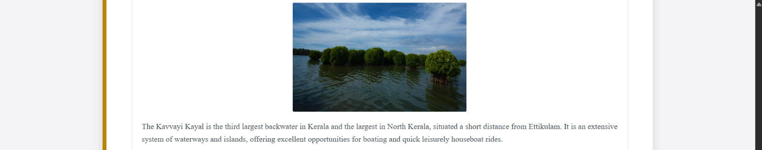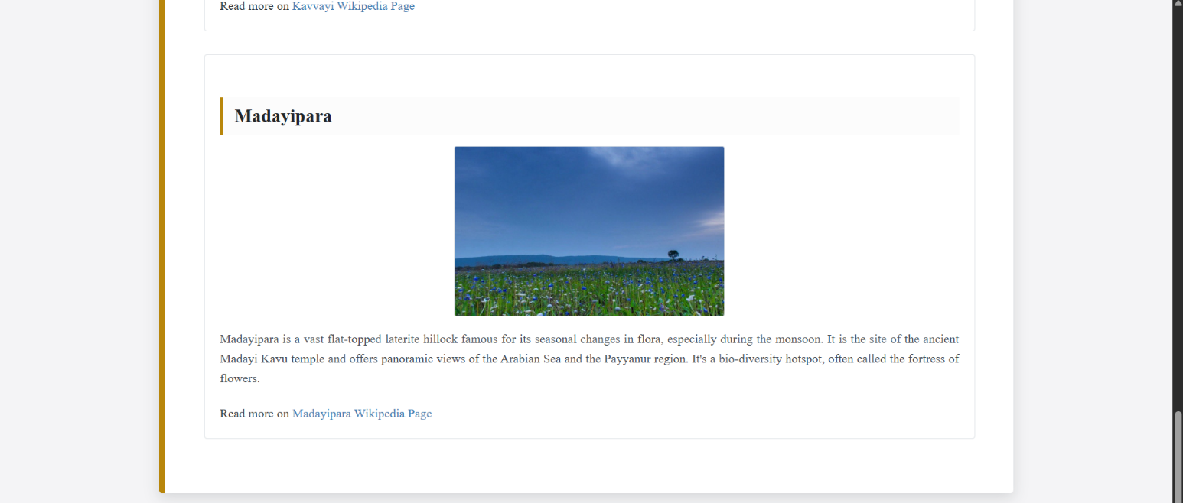

**PROGRAM 4:**

Create MITS college Website with the help of frames, style sheets, background colours, images, tables, and lists. There should be **multiple webpages** which are easily navigable by hyperlinks. Apply style sheets as well as floating, mixed, and navigation frames to design the webpages.

**PROGRAM CODE:**

**main.html**

<html>

<head>

<title>MITS Home and Navigation</title>

<link rel="stylesheet" href="college_style_red.css"> </head>

<body style="background-color: #fcfcfc;"> <header>

<div class="top-banner">

<marquee>Muthoot Institute of Technology and Science: Engineering

Excellence in Kochi!</marquee>

</div>

</header>

<center><img src="img-1.png" width="150" height="100"></center>

<center><h1 class="main-heading"><b>MUTHOOT INSTITUTE OF

TECHNOLOGY AND SCIENCE</b></h1></center>

<center><img src="img-7.webp" width="450" height="300"></center><br>

<nav class="main-nav-bar">

<a href="window.html" target="navFrame"><b>INSTITUTE

HOME</b></a>

<a href="course.html" target="contentFrame"><b>ACADEMIC

PROGRAMMES</b></a>

<a href="admission.html" target="contentFrame"><b>APPLY

ONLINE</b></a>

<a href="contact.html" target="contentFrame"><b>LOCATE & CONTACT

US</b></a>

<a href="gallery.html" target="contentFrame"><b>MEDIA

GALLERY</b></a>

</nav>

<hr>

<center><h3 class="section-title"><u>ABOUT THE

INSTITUTION</u></h3></center>

<p style="padding: 0 15px; text-align: justify;">

Muthoot Institute of Technology and Science (MITS) is proudly promoted by

Muthoot M. George Institute of Technology, a recognized Section 25 Company

operating within the vast Muthoot Group. MITS functions as a premier selffinancing

technical institution, offering a broad spectrum of postgraduate and

undergraduate engineering programmes. It is conveniently situated in the

industrial suburb of Kochi, near the Smart City and Info Park, approximately 15

kms from Vytilla Junction on the Cochin-Madurai National Highway.

<br>

The promoters, leveraging their significant presence across Financial Services,

Hospitality, Healthcare, and Information Technology, are steadfastly committed

to elevating MITS as a true centre of excellence, built entirely on academic merit.

This "temple of learning" provides students with state-of-the-art infrastructure,

highly qualified and proficient teachers across various engineering faculty,

ensuring an environment conducive to their comprehensive intellectual and

harmonious development.

</p>

<div class="mission-statement-box">

<h2 class="sub-heading">OUR VISION</h2>

<p>To establish a leading centre for excellence in learning and research in

engineering and technology, dedicated to producing intellectually competent and

socially responsible citizens possessing an impeccable ethical value system.</p>

<h2 class="sub-heading">OUR MISSION</h2>

<ul class="mission-list">

<li>To offer a comprehensive, well-balanced programme integrating rigorous

instruction, essential practical exercises, and opportunities in advanced

technology.</li>

<li>To actively foster innovation and the ideation of technological solutions on a

sustainable and responsible basis.</li>

<li>To nurture a strong value system in our students, embedding in them a

crucial spirit of inquiry and lifelong learning.</li>

</ul>

</div>

</body>

</html>

**index.html**

<html>

<head>

<title>MITS College</title>

</head>

<frameset cols="35%,65%">

<frame src="window.html" name="navFrame">

<frame src="main.html" name="contentFrame">

</frameset>

</html>

**window.html**

<html>

<head>

<title>Introduction & Welcome</title>

<link rel="stylesheet" href="college_style_red.css">

</head>

<body style="background-color: #ffffff; padding: 10px;"> <h1 class="welcomeheading">

Rooted in Tradition, Engineered for the Future</h1>

<p style="text-align: justify;">

MITS is a self-financing technical institution offering globally relevant

postgraduate and undergraduate engineering programmes. Its location in the

industrial suburb of Kochi, near the Smart City and Info Park, provides a distinct

advantage. The Muthoot Group promoters are committed to achieving centre of

excellence status, focusing purely on merit and providing world-class

infrastructure.

</p>

<center><img src="img-2.jpeg" alt="MITS Welcome Banner"

width="20%"></center>

<p style="font-style: italic; margin-top: 10px; border-top: 1px dashed #cc0000;

padding-top: 5px;">

</p>

</body>

</html>

**contact.html**

<html>

<head>

<title>Contact Us</title>

<link rel="stylesheet" href="college_style_red.css">

</head>

<body style="background-color: #fcfcfc;">

<h2 class="page-title">INSTITUTE CONTACT & LOCATION</h2>

<div class="contact-card">

<strong>HEAD OFFICE ADDRESS:</strong>

<p>Muthoot Institute of Technology and Science</p>

<p>Varikoli P.O, Puthencruz- 682308, Kerala, India.</p>

</div>

<div class="contact-card">

<strong>GENERAL ENQUIRY PHONE:</strong>

<p>0484-2732111 (Reception)</p>

<p>0484-2732100 (Admin Office)</p>

</div>

<div class="contact-card">

<strong>EMAIL CORRESPONDENCE:</strong>

<a href="mailto:info@mgits.ac.in">info@mgits.ac.in</a> (General)<br>

<a href="mailto:admissions@mgits.ac.in">admissions@mgits.ac.in</a>

(Admissions)

</div>

</body>

</html>

**course.html**

<html>

<head>

<title>Academic Programmes</title>

<link rel="stylesheet" href="college_style_red.css">

</head>

<body style="background-color: #fcfcfc;">

<h2 class="page-title">ACADEMIC PROGRAMMES OFFERED</h2>

<table class="programme-table" border="0">

<thead>

<tr>

<th>Programme Name</th>

<th>Duration (Years)</th>

<th>Approved Intake (Seats)</th>

</tr>

</thead>

<tbody>

<tr><td>B.Tech Civil Engineering (CE)</td><td>4</td><td>60</td></tr>

<tr><td>B.Tech Computer Science & Engineering

(CSE)</td><td>4</td><td>120</td></tr>

<tr><td>B.Tech Electronics & Communication Engineering

(ECE)</td><td>4</td><td>60</td></tr>

<tr><td>B.Tech Electrical & Electronics Engineering

(EEE)</td><td>4</td><td>60</td></tr>

<tr><td>B.Tech Mechanical Engineering

(ME)</td><td>4</td><td>60</td></tr>

<tr><td>B.Tech CSE (Artificial

Intelligence)</td><td>4</td><td>60</td></tr>

<tr><td>B.Tech Artificial Intelligence & Data

Science</td><td>4</td><td>60</td></tr>

<tr><td>B.Tech Cyber Security</td><td>4</td><td>60</td></tr>

<tr><td>M.Tech Artificial Intelligence & Data

Science</td><td>2</td><td>18</td></tr>

<tr><td>M.Tech Cyber Security</td><td>2</td><td>18</td></tr>

<tr><td>Master of Computer Applications

(MCA)</td><td>2</td><td>60</td></tr>

</tbody>

</table>

</body>

</html>

**gallery.html**

<html>

<head>

<title>Media Gallery</title>

<link rel="stylesheet" href="college_style_red.css">

<style>

.gallery-img {

border: 3px solid #cc0000;

margin: 15px auto;

display: block;

width: 350px;

height: 250px;

box-shadow: 2px 2px 5px rgba(0, 0, 0, 0.2);

transition: transform 0.3s;

}

.gallery-img:hover {

transform: scale(1.02);

}

.iframe-container {

width: 90%;

height: 300px;

margin: 20px auto;

border: 3px solid #ff4d4d;

}

</style>

</head>

<body style="background-color: #fcfcfc;">

<h2 class="page-title">GALLERY</h2>

<h3 style="color: #cc0000; text-align: center; margin-top: 30px;">Image

Highlights</h3>

<center>

<img src="img-6.jpeg" class="gallery-img" alt="Programs"><br>

<img src="img-5.jpeg" class="gallery-img" alt="Programs"><br>

<img src="img-4.jpeg" class="gallery-img" alt="Programs"><br>

<img src="img-3.jpg" class="gallery-img" alt="Sports Day">

</center>

</body>

</html>

**admission.html**

<html>

<head>

<title>Admission Form</title>

<link rel="stylesheet" href="college_style_red.css">

</head>

<body style="background-color: #fcfcfc;">

<h2 class="page-title" style="color: #cc0000;"><u>ONLINE APPLICATION

FOR ADMISSION</u></h2> <form class="admission-form">

<fieldset>

<legend>Applicant Personal Details</legend>

<label>Full Name:</label><br>

<input type="text" name="fullName" size="40"><br><br>

<label>Date of Birth (DD/MM/YYYY):</label><br>

<input type="date" name="dob"><br><br>

<label>Mobile Number:</label><br>

<input type="tel" name="phone" placeholder="10 Digits" required><br><br>

<label>Official Email:</label><br>

<input type="email" name="email" size="40"><br><br>

<label>Set Password (Min 6 chars):</label><br>

<input type="password" name="password" minlength="6"><br><br>

<label>Permanent Address:</label><br>

<textarea id="address" name="user_address" rows="4"

cols="45"></textarea><br><br>

<label>Gender:</label>

<input type="radio" name="gender" value="male"> Male

<input type="radio" name="gender" value="female"> Female

<input type="radio" name="gender" value="other"> Prefer not to say

<br><br>

<label>Programme:</label>

<select name="programme_select">

<option value="">-- Choose Programme --</option>

<option>MCA</option>

<option>B.Tech CIVIL ENGINEERING</option>

<option>B.Tech COMPUTER SCIENCE & ENGINEERING</option>

<option>B.Tech ELECTRONICS & COMMUNICATION

ENGINEERING</option>

<option>B.Tech ELECTRICAL & ELECTRONICS

ENGINEERING</option>

<option>B.Tech MECHANICAL ENGINEERING</option>

<option>B.Tech CSE (ARTIFICIAL INTELLIGENCE)</option>

<option>B.Tech ARTIFICIAL INTELLIGENCE & DATA

SCIENCE</option>

<option>B.Tech CYBER SECURITY</option>

<option>M.Tech CYBER SECURITY</option>

<option>M.Tech ARTIFICIAL INTELLIGENCE & DATA

SCIENCE</option>

</select><br><br>

</fieldset>

<input type="submit" value="Submit Application">

<input type="reset" value="Clear Form">

</form>

</body>

</html>

**college_style_red.css**

body {

font-family: 'Verdana', sans-serif;

color: #333;

}

.top-banner {

background-color: #cc0000;

color: white;

padding: 5px;

text-align: center;

font-size: 1.0em;

font-weight: bold;

border-bottom: 2px solid #800000;

}

.main-nav-bar {

background-color: #800000;

text-align: center;

padding: 12px 0;

margin-bottom: 20px;

box-shadow: 0 4px 8px rgba(0, 0, 0, 0.2);

}

.main-nav-bar a {

color: white;

margin: 0 20px;

text-decoration: none;

font-weight: 600;

font-size: 1.1em;

padding: 8px 15px;

transition: background-color 0.3s;

}

.main-nav-bar a:hover {

text-decoration: none;

background-color: #cc0000;

border-radius: 5px;

}

.main-heading {

color: #cc0000;

font-size: 32px;

border-bottom: 3px solid #e0e0e0;

padding-bottom: 10px;

}

.section-title {

color: #cc0000;

font-size: 24px;

}

.mission-statement-box {

width: 450px;

margin: 30px auto;

padding: 25px;

border: 3px solid #ff4d4d;

border-radius: 10px;

box-shadow: 5px 5px 15px rgba(0, 0, 0, 0.15);

background-color: #fffafa;

text-align: left;

}

.sub-heading {

font-size: 20px;

color: #800000;

margin-top: 20px;

margin-bottom: 10px;

border-left: 5px solid #cc0000;

padding-left: 12px;

display: block;

font-weight: bold;

}

.contact-card {

margin: 15px 10%;

padding: 15px;

border: 1px solid #ffd1d1;

border-radius: 5px;

background-color: #fff5f5;

}

.contact-card strong {

display: block;

color: #cc0000;

font-size: 1.2em;

margin-bottom: 8px;

border-bottom: 2px solid #ffd1d1;

padding-bottom: 5px;

}

.page-title {

color: #800000;

text-align: center;

font-size: 30px;

border-bottom: 2px solid #cc0000;

padding-bottom: 5px;

}

.programme-table {

width: 80%;

margin: 30px auto;

border-collapse: collapse;

box-shadow: 0 4px 10px rgba(0, 0, 0, 0.1);

}

.programme-table th, .programme-table td {

border: 1px solid #c0c0c0;

padding: 12px;

text-align: left;

}

.programme-table th {

background-color: #cc0000;

color: white;

font-weight: bold;

text-transform: uppercase;

}

.programme-table tr:nth-child(even) {

background-color: #f7f7f7;

}

**OUTPUT:**

**PROGRAM 5:**

Apply positioning methods of elements on a webpage with div elements and their corresponding classes using two external stylesheets. Compare the output with absolute, and relative positioning of div elements.

**PROGRAM CODE:**

**position.html**

<html>

<head>

<title>CSS Positioning Comparison</title>

<link rel="stylesheet" href="style_relative.css"> <link rel="stylesheet"

href="style_absolute.css"> <style>

.item {

height: 90px;

width: 90px;

margin: 8px;

border: 1px solid #333;

}

.absolute-container {

position: relative;

width: 650px;

height: 220px;

border: 3px dashed #004d99;

margin-top: 50px;

margin-left: 20px;

background-color: #f0f8ff;

}

.relative-flow-parent {

display: flex;

width: 650px;

height: 220px;

border: 3px solid #1a7e46;

background-color: #f7fff7;

}

h1 {

color: #004d99;

border-bottom: 2px solid #ccc;

padding-bottom: 5px;

}

p {

margin-bottom: 25px;

font-style: italic;

color: #444;

}

</style>

</head>

<body>

<h1>CSS RELATIVE POSITIONING</h1>

<p>An element with <b>position: relative;</b> is offset from its original

position. Critically, it does <b>not</b> affect the layout of other surrounding

elements, preserving their space in the normal document flow.</p>

<div class="relative-flow-parent">

<div class="item" id="cyan-box"></div>

<div class="item" id="magenta-box"></div>

<div class="item" id="orange-box"></div>

<div class="item" id="purple-box"></div>

</div>

<hr>

<h1>CSS ABSOLUTE POSITIONING</h1>

<p>An element with <b>position: absolute;</b> is removed from the normal

document flow and positioned relative to the nearest ancestor that has a position

property other than <b>static</b>. Here, the positioning ancestor is the div with

class "absolute-container", which is set to relative.</p>

<div class="absolute-container">

<div class="item" id="box-one"></div>

<div class="item" id="box-two"></div>

<div class="item" id="box-three"></div>

<div class="item" id="box-four"></div>

</div>

</body>

</html>

**style_relative.css**

#cyan-box {

position: relative;

left: 40px;

top: 15px;

background-color: #00bcd4;

}

#magenta-box {

position: relative;

left: 80px;

top: 40px;

background-color: #e91e63;

}

#orange-box {

position: relative;

left: 120px;

top: 15px;

background-color: #ff9800;

}

#purple-box {

position: relative;

left: 160px;

top: 40px;

background-color: #9c27b0;

}

background-color: #ffffff;

}

style_absolute.css

#box-one {

position: absolute;

left: 40px;

top: 10px;

background-color: #3f51b5;

}

#box-two {

position: absolute;

right: 30px;

bottom: 40px;

background-color: #f44336;

}

#box-three {

position: absolute;

left: 45%;

top: 50%;

transform: translate(-50%, -50%);

background-color: #4caf50;

}

#box-four {

position: absolute;

right: 10px;

top: 10px;

background-color: #ffc107;

}

**OUTPUT:**

**Lab Cycle 2**

**CO2: Implement client-side validation techniques using scripting languages.**

**PROGRAM 6:**

Create an HTML page to demonstrate the use of various predefined functions in a string and math object in java script.

**PROGRAM CODE:**

# main.html

<html>

<head>

<title>WPL PROGRAM 6</title>

<style>

body{

margin: 0;

padding: 25px;

background-color: #f0f8ff;

font-family: Arial, sans-serif;

}

h1{

font-size: 38px;

font-style: italic;

text-align: center;

color: #333;

}

h2{

font-size: 28px;

margin-left: 15px;

color: #0056b3;

}

h3{

margin-left: 35px;

}

input{

margin-left: 40px;

padding: 5px;

border: 1px solid #ccc;

}

p{

margin-left: 55px;

color: #555;

}

button{

margin-left: 40px;

padding: 10px 18px;

background-color: #007bff;

color: white;

border: none;

cursor: pointer;

border-radius: 5px;

transition: background-color 0.3s;

}

button:hover {

background-color: #0056b3;

}

</style>

</head>

<body>

<h1>JavaScript String and Math Functions Demonstration</h1><br>

<ol>

<li><h2>String Manipulation Methods</h2></li>

<input type="text" id="inputString" placeholder="Enter sample text (e.g., Hello

World)">

<ul>

<li><h3>String Character at Index (charAt):</h3></li>

<button onclick="stringCharAt()">Get Char (Index 4)</button><br>

<p id="charat"></p>

<li><h3>String Length Property:</h3></li>

<button onclick="stringLength()">Get Length</button><br>

<p id="length"></p>

<li><h3>String Slice:</h3></li>

<button onclick="stringSlice()">Slice (7, 13)</button><br>

<p id="sliced1"></p>

<p id="sliced2"></p>

<li><h3>String Substring:</h3></li>

<button onclick="stringSubstring()">Substring (7, 13)</button><br>

<p id="substringed1"></p>

<li><h3>String Replace:</h3></li>

<button onclick="stringReplace()">Replace 'World' with

'Students'</button><br>

<p id="original"></p>

<p id="replace"></p>

<li><h3>String to Uppercase:</h3></li>

<button onclick="stringUpperCase()">To Uppercase</button><br>

<p id="upper"></p>

<li><h3>String Concatenation:</h3></li>

<button onclick="stringConcat()">Concat with " Everyone"</button><br>

<p id="concated1"></p>

<p id="concated3"></p>

</ul>

<br><br>

<li> <h2>Mathematical Operations (Math Object)</h2></li>

<ul>

<li><h3>Rounding and Integer Methods: </h3></li>

<button onclick="numberConvertion()">Convert Number</button><br>

<p id="num">Initial number used: 15.7</p>

<ul>

<li>Math.round() : </li>

<p id="round"></p>

<li>Math.ceil() : </li>

<p id="ceil"></p>

<li>Math.floor() : </li>

<p id="floor"></p>

<li>Math.trunc() : </li>

<p id="trunc"></p>

</ul>

<li><h3>Math.sign(): </h3></li>

<p>Tests for positive, negative, or zero:</p>

<button onclick="numberSign()">Test Signs</button><br>

<p id="sign1"></p>

<p id="sign2"></p>

<p id="sign3"></p>

<li><h3>Math.pow(x, y): </h3></li>

<p>Calculates the value of x raised to the power of y :</p>

<button onclick="numberPow()">Calculate Power</button><br>

<p id="power"></p>

<li><h3>Math.sqrt(x): </h3></li>

<p>Returns the square root of x :</p>

<button onclick="numberSqrt()">Calculate Square Root</button><br>

<p id="sqrt"></p>

<li><h3>Math.abs(x): </h3></li>

<p>Returns the absolute (positive) value of x:</p>

<button onclick="numberAbs()">Get Absolute Value</button><br>

<p id="absolute"></p>

<li><h3>Math.min() and Math.max(): </h3></li>

<button onclick="numberMinMax()">Find Min and Max</button><br>

<p id="list">Using list: (10, 5, 50, -2, 100, 1)</p>

<p id="min"></p>

<p id="max"></p>

<li><h3>Math.sin(x): </h3></li>

<p>Returns the sine of a number:</p>

<button onclick="numberSin()">Calculate Sine</button><br>

<p id="sine"></p>

</ul>

</ol>

<script>

let inputElement = document.getElementById("inputString");

function stringCharAt(){

let text = inputElement.value;

let char = text.charAt(4);

document.getElementById("charat").innerHTML = "Character at index 4 is:

"+char+"";

}

function stringLength(){

let text = inputElement.value;

let len = text.length;

document.getElementById("length").innerHTML = "Total number of

characters is: "+len+"";

}

function stringSlice(){

let text = inputElement.value;

let slice1 = text.slice(7,13);

document.getElementById("sliced1").innerHTML = "Slice (7, 13) result:

"+slice1+"";

let slice2 = text.slice(-5);

document.getElementById("sliced2").innerHTML = "Slice with negative

parameter (-5) result: "+slice2+"";

}

function stringSubstring(){

let text = inputElement.value;

let substring1 = text.substring(7,13);

document.getElementById("substringed1").innerHTML = "Substring (7, 13)

result: "+ substring1+"";

}

function stringReplace(){

let text = inputElement.value;

let newtext = text.replace("World","Students");

document.getElementById("original").innerHTML = "Original string: "+text;

document.getElementById("replace").innerHTML = "String after replacement:

"+newtext+"";

}

function stringUpperCase(){

let text = inputElement.value;

let textUp = text.toUpperCase();

document.getElementById("upper").innerHTML = "Converted to

UPPERCASE: "+ textUp+"";

}

function stringConcat(){

let text = inputElement.value;

let textToAdd = " Everyone";

let text3 = text.concat(textToAdd);

document.getElementById("concated1").innerHTML = "Original Text: "+

text;

document.getElementById("concated3").innerHTML = "Concatenated Result:

"+ text3+"";

}

function numberConvertion(){

let x = 15.7;

document.getElementById("num").innerHTML = "The Number used for

rounding is: " + x+"";

document.getElementById("round").innerHTML = "Math.round(x) (Nearest

Integer): " + Math.round(x)+"";

document.getElementById("ceil").innerHTML = "Math.ceil(x) (Rounds Up): "

+ Math.ceil(x)+"";

document.getElementById("floor").innerHTML = "Math.floor(x) (Rounds

Down): " + Math.floor(x)+"";

document.getElementById("trunc").innerHTML = "Math.trunc(x) (Integer

Part): " + Math.trunc(x)+"";

}

function numberSign(){

document.getElementById("sign1").innerHTML = "Math.sign(12) returns: " +

Math.sign(12)+"";

document.getElementById("sign2").innerHTML = "Math.sign(-8) returns: " +

Math.sign(-8)+"";

document.getElementById("sign3").innerHTML = "Math.sign(0) returns: " +

Math.sign(0)+"";

}

function numberPow(){

document.getElementById("power").innerHTML = "Math.pow(5, 3) (5 cubed)

returns: " + Math.pow(5,3)+"";

}

function numberSqrt(){

document.getElementById("sqrt").innerHTML = "Math.sqrt(144) (Square

Root) returns: " + Math.sqrt(144)+"";

}

function numberAbs(){

document.getElementById("absolute").innerHTML = "Math.abs(-99.3)

(Absolute Value) returns: " + Math.abs(-99.3)+"";

}

function numberMinMax(){

let list = [10, 5, 50, -2, 100, 1];

document.getElementById("list").innerHTML ="The List is : (10, 5, 50, -2,

100, 1)";

document.getElementById("min").innerHTML ="Minimum in the list is: " +

Math.min(...list)+"";

document.getElementById("max").innerHTML ="Maximum in the list is: " +

Math.max(...list)+"";

}

function numberSin(){

let angle = Math.PI / 2;

document.getElementById("sine").innerHTML = "Math.sin(Pi/2) returns: " +

Math.sin(angle);}

</script>

</body>

</html>

**OUTPUT:**

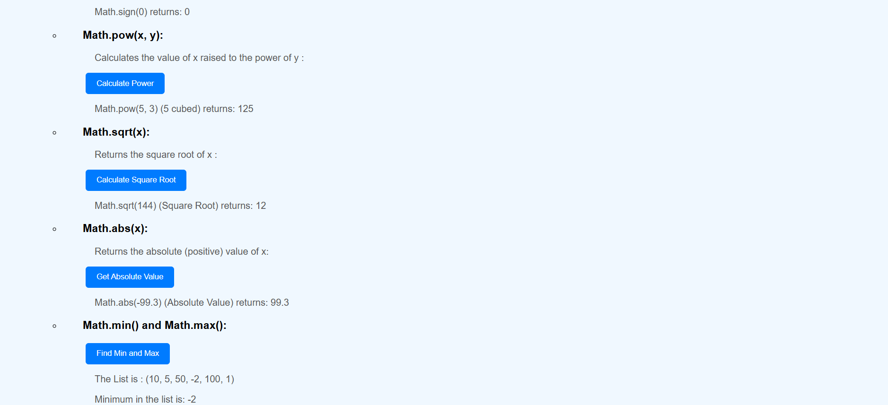

**PROGRAM 7:**

Generate a calendar using JavaScript code by getting the year and month from the user.

**PROGRAM CODE:**

# index.html

<html>

<head>

<title>Monthly Calendar Generator</title>

<link rel="stylesheet" type="text/css" href="calStyle.css">

</head>

<body>

<h2><center>MONTHLY CALENDAR GENERATOR<center></h2>

<br/>

<script src="calScript.js"></script>

Enter Year: <input id="currentYear" type="number"

name="year"><br/><br/>

Enter Month (1-12): <input id="currentMonth" type="number"

name="month"><br/><br/>

<input type="button" value="Display Calendar"

onclick="generateCalendar()"> <br/>

<br/>

<div id="calendarDisplay"></div>

</body>

</html>

calStyle.css

table {

border-collapse: collapse;

width: 60%;

margin: 20px auto;

}

td,th {

border: 1px solid #777;

padding: 7px;

text-align: center;

}

th {

font-weight: 600;

background-color: #DDEEFF;

color: #333;

}

td {

background-color: #F8F8F8;

}

calScript.js

function generateCalendar() {

let inputYear = document.getElementById("currentYear").value;

let inputMonth = document.getElementById("currentMonth").value;

let monthIndex = inputMonth - 1;

if (!inputYear || !inputMonth || inputMonth < 1 || inputMonth > 12) {

document.getElementById("calendarDisplay").innerHTML = "Please enter

a valid year and a month (1-12).";

return;

}

let currentDate = new Date(inputYear, monthIndex);

let calendarHTML =

'<table><tr><th>Sun</th><th>Mon</th><th>Tue</th><th>Wed</th><th

>Thu</th><th>Fri</th><th>Sat</th></tr><tr>';

let firstDay = currentDate.getDay();

for (let i = 0; i < firstDay; i++) {

calendarHTML += '<td></td>';

}

while (currentDate.getMonth() == monthIndex) {

calendarHTML += '<td>' + currentDate.getDate() + '</td>';

if (currentDate.getDay() == 6) {

calendarHTML += '</tr><tr>';

}

currentDate.setDate(currentDate.getDate() + 1);

}

let lastDayOfWeek = currentDate.getDay();

if (lastDayOfWeek !== 0) {

for (let i = lastDayOfWeek; i < 7; i++) {

calendarHTML += '<td></td>';

}

}

calendarHTML += '</tr></table>';

document.getElementById("calendarDisplay").innerHTML = calendarHTML;

}

**OUTPUT:**

**PROGRAM 8:**

Create a program using the JavaScript Event Listener to add multiple events on the same button.

**PROGRAM CODE:**

# WPL PG-8.html

<html>

<body>

<h2>JavaScript addEventListener()</h2>

<p>This program uses the addEventListener() method to add multiple events

on the same button.</p>

<button id="btn">Try it</button>

<p id="demo"></p>

<script>

var x = document.getElementById("btn");

x.addEventListener("mouseover", mouseOverFunction);

x.addEventListener("click", mouseClickFunction);

x.addEventListener("mouseout", mouseOutFunction);

function mouseOverFunction() {

document.getElementById("demo").innerHTML += "Moused

over!<br>";

}

function mouseClickFunction() {

document.getElementById("demo").innerHTML += "Clicked!<br>";

}

function mouseOutFunction() {

document.getElementById("demo").innerHTML += "Moused out!<br>";

}

</script>

</body>

</html>

**OUTPUT:**

**PROGRAM 9:**

Develop a JavaScript Event Handling mechanism to change the background colour of an HTML page.

**PROGRAM CODE:**

# WPL PG-9.html

<!DOCTYPE html>

<html>

<head>

<title>Change Background Colour on Mouse Click</title>

<style>

body { font-family: sans-serif; }

#container {

width: 600px;

height: 400px;

margin: 50px auto;

padding: 20px;

text-align: center;

border: 1px solid #ccc;

}

</style>

</head>

<body>

<div id="container">

<h1>Change Background Color</h1>

<p>Click HERE to change the colour</p>

</div>

<script>

const container = document.getElementById('container');

container.addEventListener('click', () => {

const colors = ['#f00', '#0f0', '#00f', '#ff0', '#0ff', '#f0f'];

const randomColor = colors[Math.floor(Math.random() * colors.length)];

container.style.backgroundColor = randomColor;

});

</script>

</body>

</html>

**OUTPUT:**

**PROGRAM 10:**

Create an HTML page to display a new image and text when the mouse comes over the existing content in the page using JavaScript Event Handling mechanism.

**PROGRAM CODE:**

**WPL PG-10.html**

<html>

<head>

<meta charset="UTF-8">

<title>Image and Text MouseOver</title>

<style>

#image-container {

position: relative;

width: 300px;

height: 200px;

background-color: #ccc;

text-align: center;

}

#image-container img {

width: 100%;

height: auto;

}

#hidden-content {

position: absolute;

top: 0;

left: 0;

width: 100%;

height: 100%;

color: white;

text-align: center;

display: none;

}

</style>

</head>

<body>

<div id="image-container">

<img src="apple.jpg" alt="Image 1">

<p id="image-text">Apple is Here</p>

<div id="hidden-content">

<img src="strawberry.png" alt="Image 2">

</div>

</div>

<script>

const imageContainer = document.getElementById('image-container');

const hiddenContent = document.getElementById('hidden-content');

const imageText = document.getElementById('image-text');

imageContainer.addEventListener('mouseover', () => {

hiddenContent.style.display = 'block';

imageText.textContent = 'Strawberry';

});

imageContainer.addEventListener('mouseout', () => {

hiddenContent.style.display = 'none';

imageText.textContent = 'Apple';

});

</script>

</body>

</html>

**OUTPUT:**

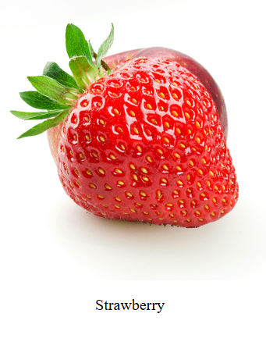

**PROGRAM 11:**

Create a HTML registration form and validate the form using JavaScript code. The validation should include the following:  
1. Name validation/Mandatory field validation  
2. password validation  
3. Email validation  
4. Mobile number validation

**PROGRAM CODE:**

**WPL PG-11.html**

<!DOCTYPE html>

<html>

<head>

<title>Registration Form Validation</title>

<style>

body { font-family: Arial, sans-serif; }

.container { width: 400px; margin: 50px auto; padding: 20px; border: 1px

solid #ccc; }

input[type="text"], input[type="password"] { width: 100%; padding: 8px;

margin: 5px 0 15px 0; display: inline-block; border: 1px solid #ccc; box-sizing:

border-box; }

.error { color: red; font-size: 0.9em; display: none; }

</style>

</head>

<body>

<div class="container">

<h2>User Registration</h2>

<form name="myform" method="post" action="#" onsubmit="return

validateform()">

<label for="name"><b>Name:</b></label>

<input type="text" placeholder="Enter Name" name="name">

<span class="error" id="nameError">Name must be filled out.</span>

<br/>

<label for="password"><b>Password:</b></label>

<input type="password" placeholder="Enter Password" name="password">

<span class="error" id="passwordError">Password must be at least 6

characters long.</span>

<br/>

<label for="email"><b>Email:</b></label>

<input type="text" placeholder="Enter Email" name="email">

<span class="error" id="emailError">Please enter a valid e-mail

address.</span>

<br/>

<label for="mobile"><b>Mobile:</b></label>

<input type="text" placeholder="Enter Mobile Number" name="mobile">

<span class="error" id="mobileError">Mobile number must be 10 digits and

numeric.</span>

<br/>

<input type="submit" value="Register">

</form>

</div>

<script>

function validateform() {

document.getElementById('nameError').style.display = 'none';

document.getElementById('passwordError').style.display = 'none';

document.getElementById('emailError').style.display = 'none';

document.getElementById('mobileError').style.display = 'none';

var name = document.myform.name.value;

var password = document.myform.password.value;

var email = document.myform.email.value;

var mobile = document.myform.mobile.value;

var isValid = true;

if (name === null || name === "") {

document.getElementById('nameError').style.display = 'block';

isValid = false;

}

if (password.length < 6) {

document.getElementById('passwordError').style.display = 'block';

isValid = false;

}

var atposition = email.indexOf("@");

var dotposition = email.lastIndexOf(".");

if (atposition < 1 || dotposition < atposition + 2 || dotposition + 2 >=

email.length) {

document.getElementById('emailError').style.display = 'block';

isValid = false;

}

if (isNaN(mobile) || mobile.length !== 10) {

document.getElementById('mobileError').style.display = 'block';

isValid = false;

}

return isValid;

}

</script>

</body>

</html>

}

});

</script>

</body>

</html>

**OUTPUT:**

**PROGRAM 12:**

Design and develop a complete online exam using Html, CSS and JavaScript. Minimum 4-5 questions should be in the online exam, and the results should be displayed on completion.

**PROGRAM CODE:**

**OnlineExam.html**

<!DOCTYPE html>

<html>

<head>

<title>JavaScript Online Exam</title>

<style>

body {

font-family: Arial;

background-color: #f4f4f4;

padding: 10px;

}

.quiz-container {

background: white;

padding: 20px;

border: 1px solid black;

width: 600px;

margin: 10px auto;

}

h2 {

color: black;

border-bottom: 1px solid black;

padding-bottom: 5px;

}

.question {

margin-bottom: 15px;

padding: 10px;

border: 1px dashed gray;

}

.question p {

font-weight: bold;

margin-bottom: 10px;

}

.options label {

display: block;

margin: 5px 0;

}

button {

padding: 8px 15px;

background-color: blue;

color: white;

border: 1px solid black;

cursor: pointer;

}

</style>

</head>

<body>

<div class="quiz-container">

<h2>Web Programming Quiz</h2>

<form id="quizForm">

<div class="question">

<p>1. What is the programming language of the Web?</p>

<div class="options">

<input type="radio" name="q1" value="A" id="q1a"><label

for="q1a">Java</label><br>

<input type="radio" name="q1" value="B" id="q1b"><label

for="q1b">JavaScript</label><br>

<input type="radio" name="q1" value="C" id="q1c"><label

for="q1c">Python</label><br>

</div>

</div>

<div class="question">

<p>2. Which JavaScript object has no constructor and uses static

methods?</p>

<div class="options">

<input type="radio" name="q2" value="A" id="q2a"><label

for="q2a">String</label><br>

<input type="radio" name="q2" value="B" id="q2b"><label

for="q2b">Array</label><br>

<input type="radio" name="q2" value="C" id="q2c"><label

for="q2c">Math</label><br>

</div>

</div>

<div class="question">

<p>3. Which method returns the value of x rounded UP to its nearest

integer?</p>

<div class="options">

<input type="radio" name="q3" value="A" id="q3a"><label

for="q3a">Math.round(x)</label><br>

<input type="radio" name="q3" value="B" id="q3b"><label

for="q3b">Math.floor(x)</label><br>

<input type="radio" name="q3" value="C" id="q3c"><label

for="q3c">Math.ceil(x)</label><br>

</div>

</div>

<div class="question">

<p>4. The HTML DOM model is constructed as a tree of...</p>

<div class="options">

<input type="radio" name="q4" value="A" id="q4a"><label

for="q4a">Data Types</label><br>

<input type="radio" name="q4" value="B" id="q4b"><label

for="q4b">Strings</label><br>

<input type="radio" name="q4" value="C" id="q4c"><label

for="q4c">Objects</label><br>

</div>

</div>

<div class="question">

<p>5. Array indexes in JavaScript are typically... </p>

<div class="options">

<input type="radio" name="q5" value="A" id="q5a"><label

for="q5a">One-based</label><br>

<input type="radio" name="q5" value="B" id="q5b"><label

for="q5b">Zero-based</label><br>

<input type="radio" name="q5" value="C" id="q5c"><label

for="q5c">String-based</label><br>

</div>

</div>

<div class="question">

<p>6. The getMonth() method returns the month as a number ranging

from...</p>

<div class="options">

<input type="radio" name="q6" value="A" id="q6a"><label

for="q6a">1 to 12</label><br>

<input type="radio" name="q6" value="B" id="q6b"><label

for="q6b">0 to 11</label><br>

<input type="radio" name="q6" value="C" id="q6c"><label

for="q6c">1 to 31</label><br>

</div>

</div>

<div class="question">

<p>7. JavaScript objects are written with which type of bracket?</p>

<div class="options">

<input type="radio" name="q7" value="A" id="q7a"><label

for="q7a">Square Brackets []</label><br>

<input type="radio" name="q7" value="B" id="q7b"><label

for="q7b">Parentheses ()</label><br>

<input type="radio" name="q7" value="C" id="q7c"><label

for="q7c">Curly Braces {}</label><br>

</div>

</div>

<div class="question">

<p>8. Which operator can be used to add (concatenate) strings?</p>

<div class="options">

<input type="radio" name="q8" value="A" id="q8a"><label

for="q8a">- (Subtraction)</label><br>

<input type="radio" name="q8" value="B" id="q8b"><label

for="q8b">+ (Addition)</label><br>

<input type="radio" name="q8" value="C" id="q8c"><label

for="q8c">! (Logical NOT)</label><br>

</div>

</div>

<div class="question">

<p>9. The most common way to access an HTML element is by

its...</p>

<div class="options">

<input type="radio" name="q9" value="A" id="q9a"><label

for="q9a">Tag Name</label><br>

<input type="radio" name="q9" value="B" id="q9b"><label

for="q9b">Class Name</label><br>

<input type="radio" name="q9" value="C" id="q9c"><label

for="q9c">ID</label><br>

</div>

</div>

<div class="question">

<p>10. The DOM Level 2 method to register an event handler is...</p>

<div class="options">

<input type="radio" name="q10" value="A" id="q10a"><label

for="q10a">onclick</label><br>

<input type="radio" name="q10" value="B" id="q10b"><label

for="q10b">attachEvent()</label><br>

<input type="radio" name="q10" value="C" id="q10c"><label

for="q10c">addEventListener()</label><br>

</div>

</div>

<button type="button" onclick="checkAnswers()">Submit</button>

</form>

<div id="results"></div>

</div>

<script>

function checkAnswers() {

const correctAnswers = {

q1: 'B',

q2: 'C',

q3: 'C',

q4: 'C',

q5: 'B',

q6: 'B',

q7: 'C',

q8: 'B',

q9: 'C',

q10: 'C'

};

let score = 0;

const totalQuestions = Object.keys(correctAnswers).length;

const form = document.getElementById('quizForm');

const resultsDiv = document.getElementById('results');

for (let i = 1; i <= totalQuestions; i++) {

const questionName = 'q' + i;

const selectedOption = form.elements[questionName].value;

if (selectedOption === correctAnswers[questionName]) {

score++;

}

}

const percentage = (score / totalQuestions) * 100;

resultsDiv.innerHTML = `

<p>Result:</p>

<p>Score: ${score} / ${totalQuestions}</p>

<p>Percentage: ${percentage.toFixed(1)}%</p>

`;

}

</script>

</body>

</html>

QuizScript.js

function checkAnswers() {

const correctAnswers = {

q1: 'B',

q2: 'C',

q3: 'C',

q4: 'C'

};

let score = 0;

const totalQuestions = Object.keys(correctAnswers).length;

const form = document.getElementById('quizForm');

const resultsDiv = document.getElementById('results');

for (let i = 1; i <= totalQuestions; i++) {

const questionName = 'q' + i;

const selectedOption = form.elements[questionName].value;

if (selectedOption === correctAnswers[questionName]) {

score++;

}

}

resultsDiv.innerHTML = `

<p>Quiz Completed!</p>

<p>Your Score: ${score} out of ${totalQuestions}</p>

<p>${(score / totalQuestions) * 100}% Correct</p>

`;

}

**OUTPUT:**

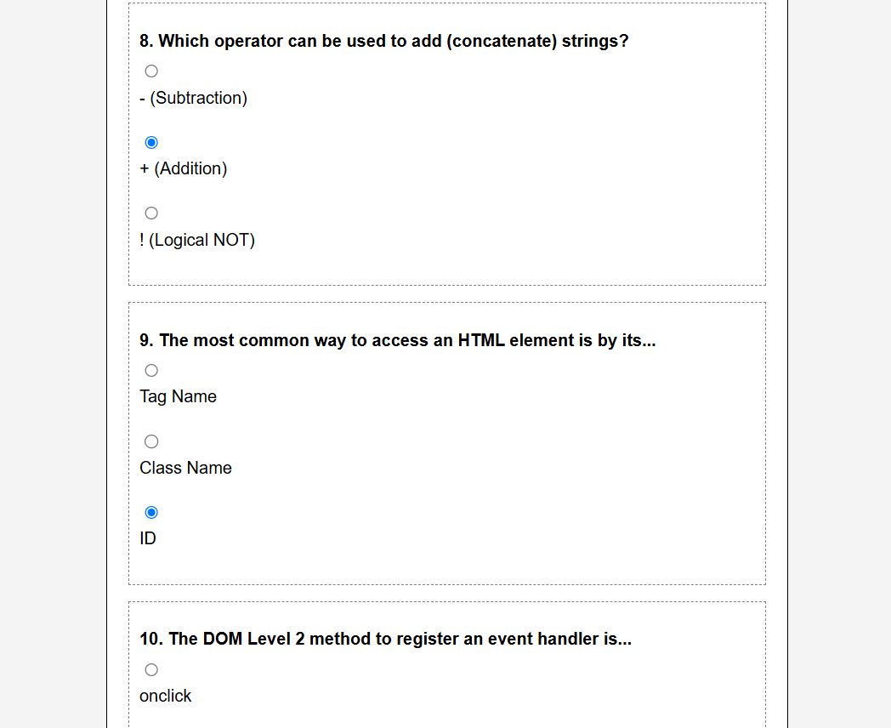

**Lab Cycle 3**

**CO3: Create functional components using both client-side and server-side scripting to support dynamic web behaviour.**

**PROGRAM 13:**

Build a PHP code to store name of students in an array and display it using print_r function. Sort and display the same using asort & arsort functions.

**PROGRAM CODE:**

**WPL PG-13.php**

<!DOCTYPE html>

<html>

<head>

<title>Array Sorting</title>

</head>

<body>

<?php

$students = array(

"R003" => "Zain",

"R001" => "Zia",

"R005" => "Adam",

"R002" => "Charles",

"R004" => "Elsa"

);

echo "<h2>1. Original Student Array (using print_r)</h2>";

echo "<pre>";

print_r($students);

echo "</pre>";

asort($students);

echo "<h2>2. Sorted Ascending by Name (using asort)</h2>";

echo "<pre>";

print_r($students);

echo "</pre>";

arsort($students);

echo "<h2>3. Sorted Descending by Name (using arsort)</h2>";

echo "<pre>";

print_r($students);

echo "</pre>";

?>

</body>

</html>

**OUTPUT:**

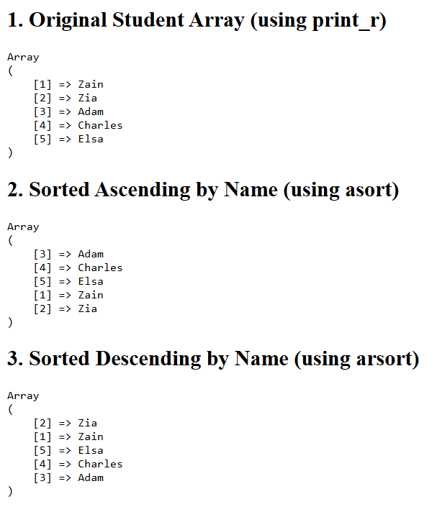

**PROGRAM 14:**

Build a PHP code to store name of Indian Cricket players in an array and display the same in HTML table.

**PROGRAM CODE:**

**WPL PG-14.php**

<!DOCTYPE html>

<html>

<head>

<title>Cricket Team Table</title>

<style>

body { font-family: Arial, sans-serif; margin: 20px; }

table { width: 400px; border-collapse: collapse; margin-top: 20px; }

th, td { border: 1px solid #000; padding: 10px; text-align: left; }

th { background-color: #f2f2f2; color: #333; }

h1 { color: #007bff; }

</style>

</head>

<body>

<h1>Indian Cricket Players List</h1>

<?php

$players = array(

"Rohit Sharma",

"Virat Kohli",

"Jasprit Bumrah",

"KL Rahul",

"Hardik Pandya",

"Ravindra Jadeja",

"Mohammed Siraj",

"Shreyas Iyer"

);

echo "<table>";

echo "<thead>";

echo "<tr><th>S. No.</th><th>Player Name</th></tr>";

echo "</thead>";

echo "<tbody>";

$serial_number = 1;

foreach ($players as $name) {

echo "<tr>";

echo "<td>" . $serial_number . "</td>";

echo "<td>" . $name . "</td>";

echo "</tr>";

$serial_number++;

}

echo "</tbody>";

echo "</table>";

?>

<p style="margin-top: 25px; font-size: 0.9em; color: #666;">

The PHP array was created and the content was dynamically inserted into

the HTML table using the <code>foreach</code> loop and

<code>echo</code> statements.

</p>

</body>

</html>

**OUTPUT:**

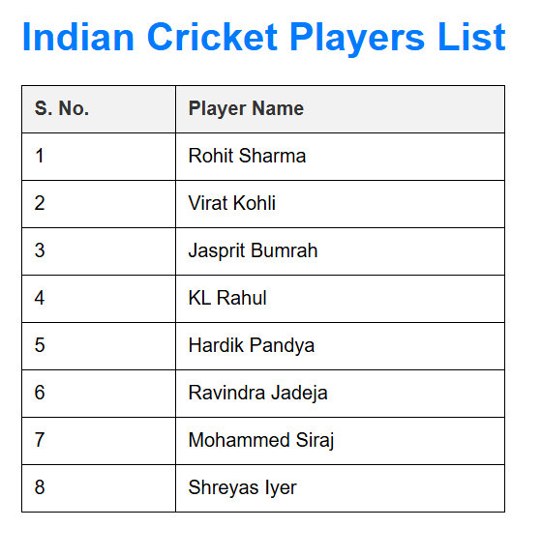

**PROGRAM 15:**

Design a registration form in HTML, and do necessary server side validations using PHP.

**PROGRAM CODE:**

**WPL PG-15.php**

<!DOCTYPE html>

<html>

<head>

<title>Registration Form and Validation</title>

<style>

body { font-family: Arial, sans-serif; margin: 20px; background-color:

#f4f4f4; }

.container { max-width: 450px; margin: 0 auto; background-color: #fff;

padding: 30px; border-radius: 8px; box-shadow: 0 2px 4px rgba(0,0,0,0.1); }

h1 { color: #007bff; text-align: center; margin-bottom: 25px; }

label { display: block; margin-bottom: 5px; font-weight: bold; }

input[type="text"], input[type="email"], input[type="password"] {

width: 100%; padding: 8px; margin-bottom: 15px; border: 1px solid #ccc;

border-radius: 4px; box-sizing: border-box;

}

input[type="submit"] { background-color: #28a745; color: white; padding:

10px 15px; border: none; border-radius: 4px; cursor: pointer; }

.error { color: #dc3545; font-size: 0.9em; margin-left: 10px; }

.success { color: #28a745; font-weight: bold; text-align: center; padding:

15px; background-color: #d4edda; border-radius: 4px; }

</style>

</head>

<body>

<?php

$nameErr = $emailErr = $passwordErr = "";

$name = $email = $password = "";

$is_submitted = false;

$form_valid = false;

function test_input($data) {

$data = trim($data);

$data = stripslashes($data);

$data = htmlspecialchars($data);

return $data;

}

if ($_SERVER["REQUEST_METHOD"] == "POST") {

$is_submitted = true;

if (empty($_POST["name"])) {

$nameErr = "Name is required";

} else {

$name = test_input($_POST["name"]);

}

if (empty($_POST["email"])) {

$emailErr = "Email is required";

} else {

$email = test_input($_POST["email"]);

if (!filter_var($email, FILTER_VALIDATE_EMAIL)) {

$emailErr = "Invalid email format";

}

}

if (empty($_POST["password"])) {

$passwordErr = "Password is required";

} else {

$password = test_input($_POST["password"]);

}

if (empty($nameErr) && empty($emailErr) && empty($passwordErr)) {

$form_valid = true;

}

}

?>

<div class="container">

<h1>Student Registration Form</h1>

<?php

if ($is_submitted && $form_valid) {

echo "<div class='success'>";

echo "Registration Successful!<br>";

echo "Data Submitted: Name: $name, Email: $email";

echo "</div>";

} else {

?>

<form method="post" action="<?php echo

htmlspecialchars($_SERVER["PHP_SELF"]);?>">

<label for="name">Full Name</label>

<input type="text" id="name" name="name"

value="<?php echo htmlspecialchars($name); ?>">

<span class="error">* <?php echo $nameErr; ?></span>

<label for="email">Email Address</label>

<input type="email" id="email" name="email"

value="<?php echo htmlspecialchars($email); ?>">

<span class="error">* <?php echo $emailErr; ?></span>

<label for="password">Password</label>

<input type="password" id="password" name="password">

<span class="error">* <?php echo $passwordErr; ?></span>

<input type="submit" value="Register">

</form>

<?php

}

?>

<p style="text-align: center; margin-top: 20px; font-size: 0.8em; color:

#6c757d;">

* Indicates a required field. Server-side validation performed by PHP.

</p>

</div>

</body>

</html>

**OUTPUT:**

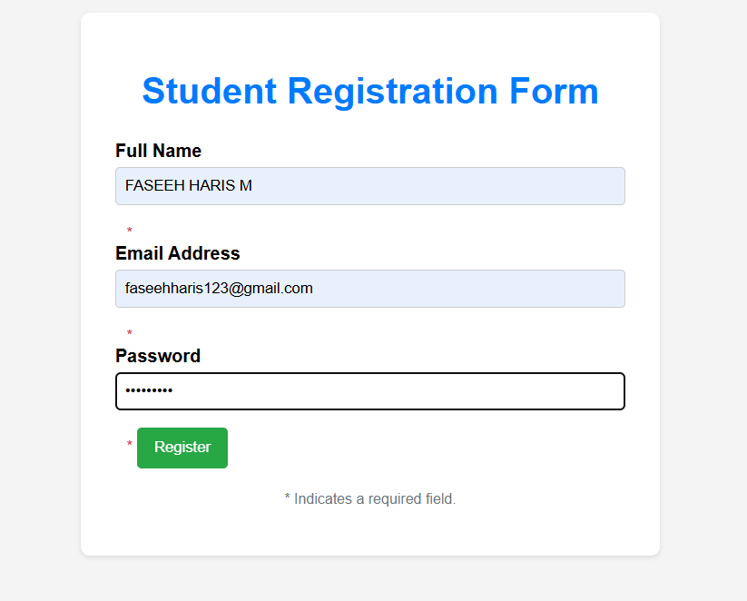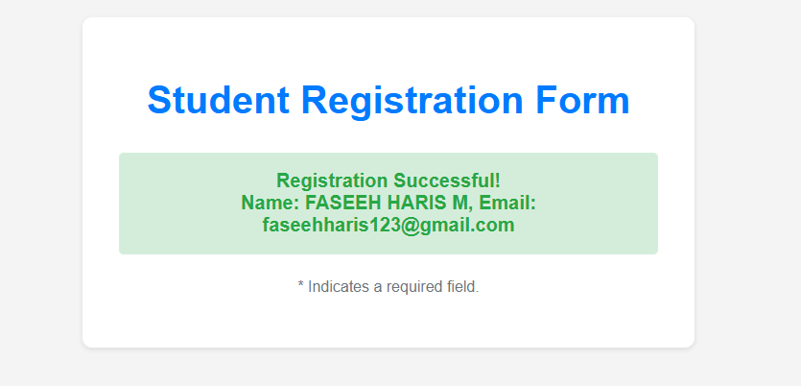

**PROGRAM 16:**

Develop a user-friendly electricity bill calculator using HTML and PHP. Collect the consumer data, and the units used, through an input form. Based on the given tariff, calculate the consumer bill amount.

**PROGRAM CODE:**

**WPL PG-16.php**

<!DOCTYPE html>

<html>

<head>

<title>Electricity Bill Calculator</title>

<style>

body { font-family: Arial, sans-serif; margin: 20px; background-color:

#f0f0f0; }

.container { max-width: 400px; margin: 0 auto; background-color: #fff;

padding: 25px; border-radius: 8px; box-shadow: 0 0 10px rgba(0,0,0,0.1); }

h1 { color: #007bff; text-align: center; border-bottom: 2px solid #ccc;

padding-bottom: 10px; margin-bottom: 20px; }

label { display: block; margin-bottom: 5px; font-weight: bold; }

input[type="text"], input[type="number"] { width: 100%; padding: 8px;

margin-bottom: 15px; border: 1px solid #ccc; border-radius: 4px; box-sizing:

border-box; }

input[type="submit"] { background-color: #28a745; color: white; padding:

10px 15px; border: none; border-radius: 4px; cursor: pointer; width: 100%; }

.result { margin-top: 20px; padding: 15px; border: 1px solid #007bff;

background-color: #e6f7ff; border-radius: 4px; }

.result h2 { color: #dc3545; margin-top: 0; }

</style>

</head>

<body>

<?php

$consumer_name = "";

$units_used = 0;

$total_bill = 0;

$result_display = "";

if ($_SERVER["REQUEST_METHOD"] == "POST") {

$consumer_name = htmlspecialchars($_POST['consumer_name'] ?? '');

$units_used = (int)($_POST['units_used'] ?? 0);

$rate_tier1 = 5.00;

$rate_tier2 = 7.50;

$rate_tier3 = 10.00;

if ($units_used <= 0) {

$result_display = "Please enter a valid number of units consumed.";

} elseif ($units_used <= 100) {

$total_bill = $units_used * $rate_tier1;

} elseif ($units_used <= 200) {

$cost_tier1 = 100 * $rate_tier1;

$remaining_units = $units_used - 100;

$cost_tier2 = $remaining_units * $rate_tier2;

$total_bill = $cost_tier1 + $cost_tier2;

} else {

$cost_tier1 = 100 * $rate_tier1;

$cost_tier2 = 100 * $rate_tier2;

$remaining_units = $units_used - 200;

$cost_tier3 = $remaining_units * $rate_tier3;

$total_bill = $cost_tier1 + $cost_tier2 + $cost_tier3;

}

$total_bill_formatted = number_format((float)$total_bill, 2);

if ($units_used > 0) {

$result_display = "<div class='result'>";

$result_display .= "<h2>Bill Details</h2>";

$result_display .= "<p><strong>Consumer:</strong> " . $consumer_name

. "</p>";

$result_display .= "<p><strong>Units Used:</strong> " . $units_used . "

units</p>";

$result_display .= "<p><strong>Total Amount Due:</strong> <span

style='font-size: 1.2em; color: #dc3545;'>Rs. " . $total_bill_formatted .

"</span></p>";

$result_display .= "</div>";

}

}

?>

<div class="container">

<h1>Electricity Bill Calculator</h1>

<div style="margin-bottom: 20px; padding: 10px; border: 1px dashed #ffa07a;

border-radius: 4px; font-size: 0.9em;">

<strong>Tariff:</strong><br>

1 - 100 units: Rs. 5.00/unit<br>

101 - 200 units: Rs. 7.50/unit<br>

201+ units: Rs. 10.00/unit

</div>

<form method="post" action="<?php echo

htmlspecialchars($_SERVER["PHP_SELF"]);?>">

<label for="consumer_name">Consumer Name</label>

<input type="text" id="consumer_name" name="consumer_name" required

value="<?php echo htmlspecialchars($consumer_name); ?>"

placeholder="Enter name">

<label for="units_used">Units Consumed</label>

<input type="number" id="units_used" name="units_used" required

min="0"

value="<?php echo htmlspecialchars($units_used); ?>"

placeholder="Enter total units">

<input type="submit" value="Calculate Bill">

</form>

<?php echo $result_display; ?>

</div>

</body>

</html>

**OUTPUT:**

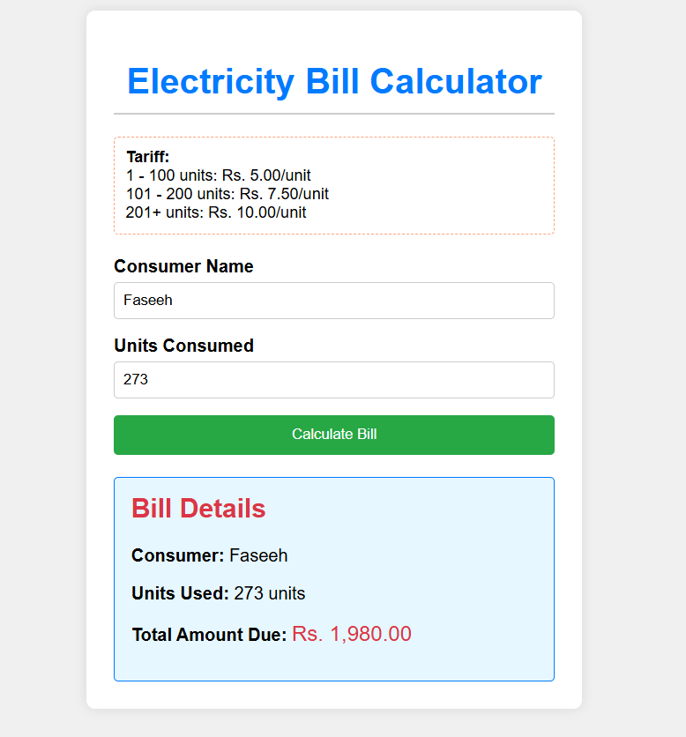

**Lab Cycle 4**

**CO4: Develop programs to link front-end interfaces with back-end databases to enable data storage, retrieval, and processing.**

**PROGRAM 17:**

Develop a PHP program to connect to a database and retrieve data from a table and show the details in a neat format.

**PROGRAM CODE:**

**WPL PG-17.php**

<!DOCTYPE html>

<html>

<head>

<title>Database Data Retrieval</title>

</head>

<body>

<h1>Database Data Retrieval</h1>

<?php

$conn = mysqli_connect("localhost", "root", "", "mca");

if (!$conn) {

die("Connection failed: " . mysqli_connect_error());

}

echo "Connected Successfully to database: mca<br><br>";

$sql = "SELECT fname, pno, email FROM student";

$result = mysqli_query($conn, $sql);

if (mysqli_num_rows($result) > 0) {

echo "<h2>Retrieved Student Records</h2>";

echo "<table border='1'>";

echo "<thead><tr><th>Full Name</th><th>Phone

Number</th><th>Email</th></tr></thead>";

echo "<tbody>";

while($row = mysqli_fetch_assoc($result)) {

echo "<tr>";

echo "<td>" . $row["fname"] . "</td>";

echo "<td>" . $row["pno"] . "</td>";

echo "<td>" . $row["email"] . "</td>";

echo "</tr>";

}

echo "</tbody>";

echo "</table>";

} else {

echo "<p>0 records found in the table (student).</p>";

}

mysqli_close($conn);

?>

</body>

</html>

**OUTPUT:**

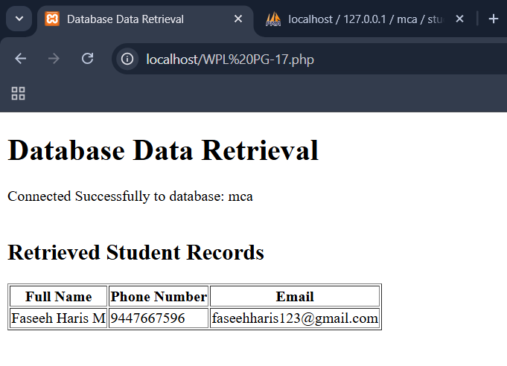

**Lab Cycle 5**

**CO5: Assemble and deploy complete web applications by integrating interface design, scripting, and database connectivity.**

**PROGRAM 18:**

Develop an application in PHP and MySQL, to accept book details viz. Book id, title, authors, edition and publisher from an HTML form in a web page and save the records in a MySQL database on submission. The program also should include a search function given the author's name, and display the search results.

**PROGRAM CODE:**

**WPL PG-18.php**

<!DOCTYPE html>

<!DOCTYPE html>

<html>

<head>

<title>Book Inventory</title>

</head>

<body>

<div id="regform">

<h1>Book Inventory System</h1>

<h3>Book Details Entry Form</h3>

<form name="bookForm" action="WPL PG-18.php" method="post">

<label for="book_id">Book ID:</label>

<input type="text" id="book_id" name="book_id" required> <br><br>

<label for="title">Title:</label>

<input type="text" id="title" name="title" required> <br><br>

<label for="authors">Authors:</label>

<input type="text" id="authors" name="authors" required> <br><br>

<label for="edition">Edition:</label>

<input type="text" id="edition" name="edition" > <br><br>

<label for="publisher">Publisher:</label>

<input type="text" id="publisher" name="publisher" > <br><br>

<input type="submit" name="submit_insert" value="Submit"><br><br>

</form>

<hr>

<h4>Search Book by Author</h4>

<form name="searchForm" action="WPL PG-18.php" method="post">

<label for="search_author">Author Name:</label>

<input type="text" name="search_author_name" required>

<input type="submit" name="search_book" value="Search"><br><br>

</form>

<?php

$conn = mysqli_connect("localhost","root","","test");

if (!$conn) {

die("Connection failed: " . mysqli_connect_error());

}

echo "Connected successfully<br>";

if (isset($_POST['submit_insert'])) {

$book_id = $_POST['book_id'];

$title = $_POST['title'];

$authors = $_POST['authors'];

$edition = $_POST['edition'];

$publisher = $_POST['publisher'];

echo " The values are: ".'<br>';

echo "Book ID: ".$book_id.'<br>';

echo "Title: ".$title.'<br>';

echo "Authors: ".$authors.'<br>';

$sql = "INSERT INTO books (book_id, title, authors, edition, publisher)

VALUES ('$book_id', '$title', '$authors', '$edition', '$publisher')";

if (mysqli_query($conn, $sql)) {

echo "<br><b>New record created successfully</b><br>";

} else {

echo "<br><b>Error:</b> " . $sql . "<br>" . mysqli_error($conn) .

"<br>";

}

}

if(isset($_POST['search_book'])) {

$search_author_name = $_POST['search_author_name'];

$sql = "SELECT book_id, title, authors, edition, publisher FROM books

WHERE authors LIKE '%$search_author_name%'";

$res = mysqli_query($conn, $sql);

$totRows = mysqli_num_rows($res);

echo "<h2>Search Results</h2>";

echo "Searched for Author: <b>$search_author_name</b><br>";

if($totRows == 0) {

echo "<b>No records found!</b><br>";

} else {

echo "<table border='1' cellpadding='5'>";

echo "<tr><th>Book

ID</th><th>Title</th><th>Authors</th><th>Edition</th><th>Publisher</

th></tr>";

while($row = mysqli_fetch_assoc($res)) {

echo "<tr>";

echo "<td>".$row["book_id"]."</td>";

echo "<td>".$row["title"]."</td>";

echo "<td>".$row["authors"]."</td>";

echo "<td>".$row["edition"]."</td>";

echo "<td>".$row["publisher"]."</td>";

echo "</tr>";

}

echo "</table>";

}

}

mysqli_close($conn);

?>

</div>

</body>

</html>

**OUTPUT:**

